"Compressed Air Engineering"
...the brochure with practical tips and suggestions plus a full coverage of the fundamentals.
In almost every branch of industry, compressed air has become an indispensable aid to efficient working and production. The economics of its use as an energy medium, however, are very much dependent on the economics of its generation, treatment and delivery. In designing a compressed air system many factors have to be taken into account and many pitfalls await the unwary or uninformed. Seemingly cost effective solutions can turn out expensive or unreliable in the long term.

Publishing "Compressed Air Engineering" Kaeser Kompressoren attempts to help the user and show him means of acquiring the compressed air he needs in the most economic way. An updated version of this brochure is out now, covering a wide spectrum of subjects from answering the question, "What is compressed air?" to designing complete air supply systems and delivery networks. The topic of optimizing existing air systems is also comprehensively covered and the reader is offered a wealth of practical tips as well as a solid grounding in the fundamentals of the technology.

The brochure can be downloaded free of charge or ordered at Kaeser Kompressoren.

File: l-compressed-air-engineering-en
1.254 Keystrokes − Free for publication, Copy appreciated

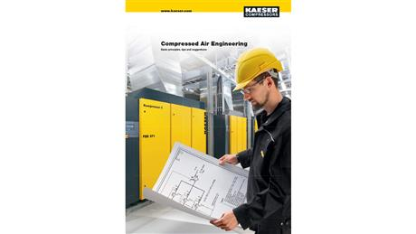
The latest edition of "Compressed Air Engineering" gives plenty of useful tips and suggestions as well as covering the fundamentals of air supply, treatment and delivery.

